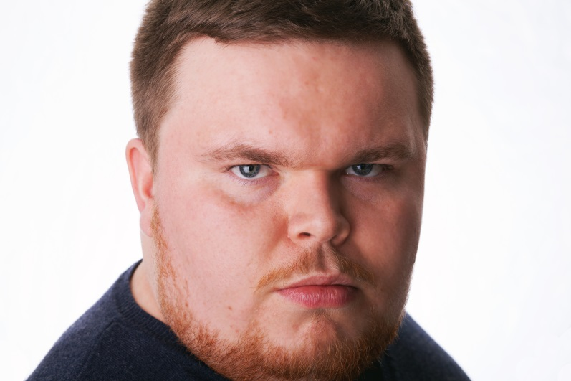
Eddy MacKenzie

2/2, 5 Bellgrove Street, Glasgow, G31 1AF
tel: 07449342972
eddymackenzieacting@gmail.com
Height – 5”5
Hair – Light Brown/blonde
Eyes – Blue

Skills
Accents: Scottish* (Standard, Glasgow, Inverness); American (New York, General, Southern); English (Cockney, Liverpool, RP, Somerset, Standard); Irish (Donegal, Northern); Welsh (General).
Music: Guitar/bass/harmonica Singing – Baritone/Tenor/Rock Vocals
Other Skills: Audio Editing, Improvisation, Skateboarding, Stage Combat.

Film
Production Character Date Director/Company

Hindsight Domino 2016 Steven McDonnell/Glasgow Film Crew

‘Twas the Fight before Ned 2015 Graeme Cassels/Glasgow Film Crew
Christmas

Merry Glitchmas Santa 2015 Laurence Chan/Glasgow Art School

Reflections of the Harry Dobbs 2015 Andrew Gunn/Glasgow Film Crew
Private Eye

Bruar Bruar 2015 Graeme Cassels/Glasgow Film Crew
Yuriko Jack 2015 Antony Scott/Utopia Film Productions

The Ballad of Dusty The King 2014 Andrew Gunn/Glasgow Film Crew

Beaumont

Dave The Storyteller 2013 Bartek Kloc/Cardonald College
Note Andrew 2012 Akbar Khan/Autumn Films
The Walking Plague Hammer 2012 Dan Lowrie/Follow The Rabbit

Theatre
Eve Barry 2016 Andrew Gunn/Deep Fried Noir
The Golden Ticket Pat 2016 Stuart Hazell/Shug The Dug Productions
The Wind in the Willows Mr Toad 2015 Alex Mitchell/Folksy Theatre
Crime and Punishment Zametov 2015 Stewart Campbell/The Shed
Eve Barry 2014 Ailsa Lonsdale/Wee Theaters
Belgrade Terminal Royce 2014 Andrew Gunn/Wee Theaters
Don’t Wake The Baby Rob 2014 Andrew Gunn/Wee Theaters
Taming of The Shrew Baptista 2014 Tom Hardwicke/Folksy Theatre
Flight of the Earls Daragh 2014 Mark Williamson/Sweet for Addicts
Crime and Punishment Zametov 2014 Stewart Campbell/Rutherglen Town Hall
3 Days ‘til Christmas Jolly 2013 Garry Curran/All About Change
Jack and the Beanstalk King Seamus 2012 Effie Scott/Shows on a Shoestring
The Tempest Trinculo 2011 Joanne Davy/Coatbridge College

Voice Over
Bruar Bruar Webseries 2016 Graeme Cassells
Rogue Announcer Stand-Up Show 2016 Richard Brown
RS100 Hire Radio Advert 2013 Pulse 98.4
We Need you! Radio Advert 2013 Radio Magnetic
Father Christmas Radio Jingle 2012 Pulse 98.4

Workshops
Performing Shakespeare - Bard in the Botanics
Physical Communication - Birds Of Paradise
Peter Pan Workshop - National Theatre of Scotland

